FACULTY OF NURSING AND MIDWIFERY
The faculty of Nursing and Midwifery offers nursing and midwifery programs which are accredited by Nurses and Midwifery Council of Malawi. The College trains frontline professional nurses and midwives who work in diverse health settings when they have graduated.
Goal
The goals of faculty of Nursing and midwifery are to produce frontline professional nurses and midwives who will offer quality nursing and midwifery care in diverse health settings.
Faculty profile
The faculty of Nursing and Midwifery is headed by Dean of Nursing and Midwifery who works hand in hand with Nursing and midwifery program coordinators and highly qualified lecturers. Below is the frontline profile for Faculty of Nursing and midwifery

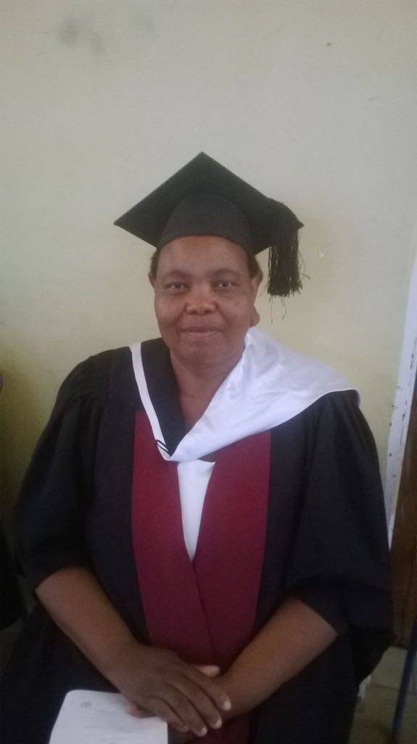
Violet V.C Kaonga
(MSc in Nursing and Midwifery Education)
Dean of Nursing and Midwifery

Febbie Magawa
(BSc in nursing and Midwifery Education )
Diploma in nursing and Midwifery ( RN) Programs coordinator

Amos Chunga
(BSc in Nursing Education )
Diploma in Nursing and Midwifery Technician Coordinator

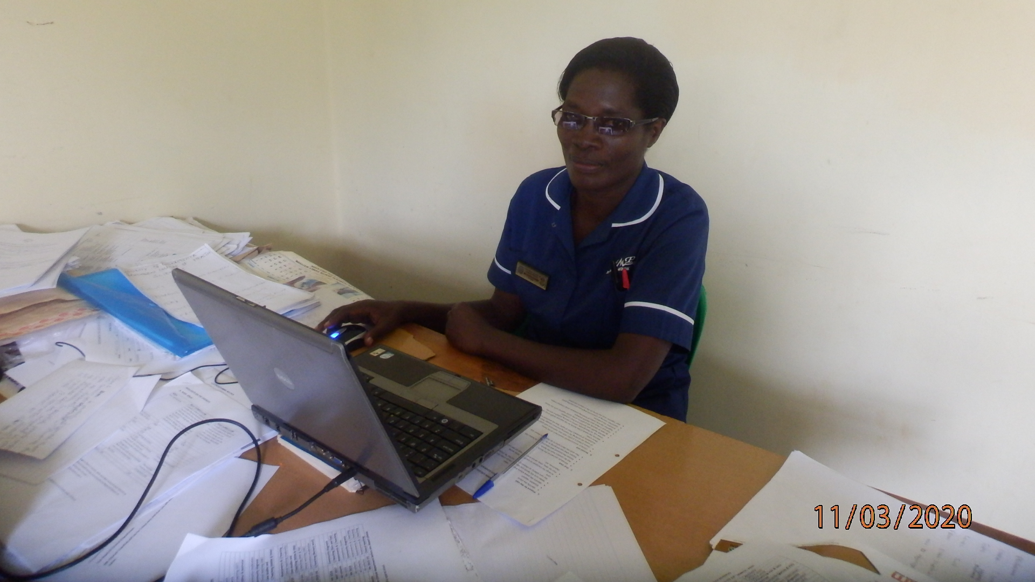
Dorothy Nyirongo
(Msc in Community Health Nursing)
Certificate in Community Midwifery assistant program coordinator
------------------------------------------------------------------------------------------------------------------------------------------

PROGRAMS OFFERED
- Diploma in Nursing and Midwifery ( Up - grading)
This is a two years program that integrates theoretical and Practical aspects of nursing and midwifery practice. The program is offered through E- learning using a blended approach; thus short period of face- to face learning followed by long period of learning through internet. Upon completion of the program and passing licensure examination the candidates is certified as a Registered nurse and Midwife

1.1 Entry requirements
Candidate must have the following:
- Be an Enrolled Nurse Midwife or Nurse Midwife Technician.
- Must have Malawi School Certificate of Education (MSCE) or its equivalent with six credits in Mathematics, Biology, Physical Science, English or English Language and any other two subjects.
- Current registration with the Nurses and Midwives Council of Malawi
- Minimum of 3 years work experience

2.0 Diploma in nursing (generic)
This is a three years program that integrates theoretical and Practical aspects of nursing and midwifery practice. The program is offered on full time face to face approach. Upon completion of the program and passing licensure examination the candidates is certified as a Registered nurse.

2.1 Entry requirements
Malawi School Certificate of Education (MSCE) or its equivalent with six credits in Mathematics, Biology, Physical Science or physics and chemistry, English Language and any other two subjects.

3.0 Diploma in Nursing and Midwifery Technician (NMT)
This is a three years program that integrates theoretical and Practical aspects of nursing and midwifery practice. The program is offered on full time face to face approach. Upon completion of the program and passing licensure examination the candidates is certified as a Nursing and Midwifery Technician ( NMT)
Entry requirements
Malawi School Certificate of Education (MSCE) or its equivalent with at least a credit in either Physical Science or Biology or General Science, and at least a strong pass in either Physical Science or Biology plus any two other credits in any of the following: Mathematics, Agriculture, Geography and Home Economics. If the candidate has credits in physical science/ physic and chemistry and biology, he/she should have one credit from the list of other subjects.

4.0 Certificate in Community Midwifery Assistant (CMA)
This is an eighteen months program that integrates theoretical and Practical aspects of midwifery practice. The program is offered on full time face to face approach. Upon completion of the program and passing licensure examination the candidates is certified as a community midwife assistant

Entry requirements
Malawi School Certificate of Education (MSCE) with a strong pass in Biology, Physical Science/ physics and chemistry and Mathematics

4.1 How to apply
The college has two intakes per year. Usually May and September intakes. It does call for admissions from time to time. For more, go to (admissions/announcements….??)

5.0 Training in mentorship
The faculty of Nursing and midwifery in order to improve teaching and learning activities, it conducts a practice based six months mentorship to clinical nurses and midwives that are directly involved in teaching and learning of students. Upon completion of mentorship, nurses and midwives are given a practice based mentorship certificate.

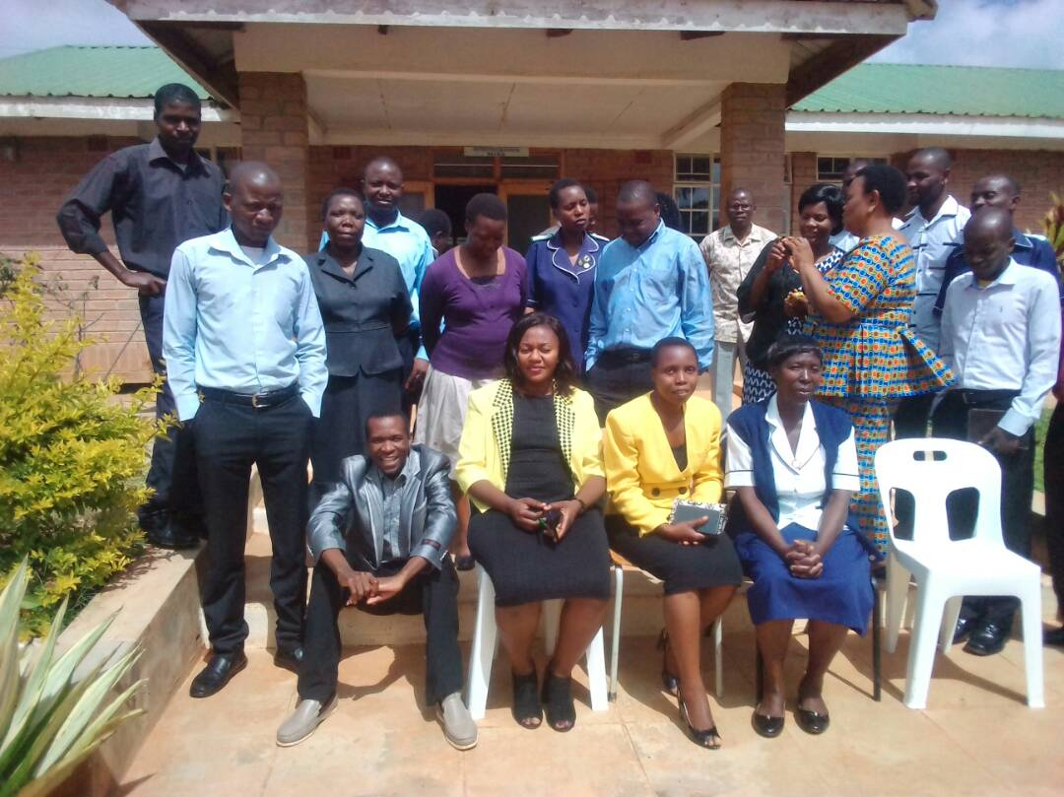
Principal mentors as well as faculty members of ECHOS

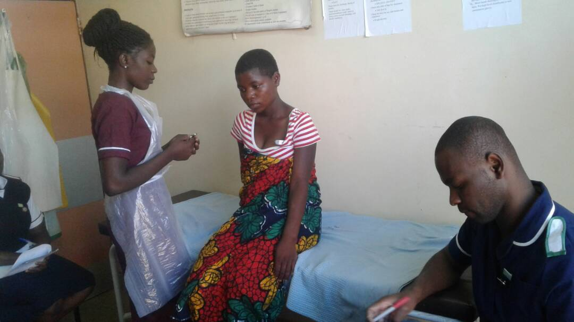
Clinical teaching

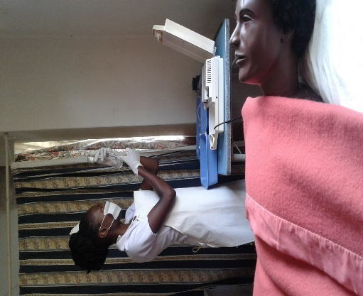
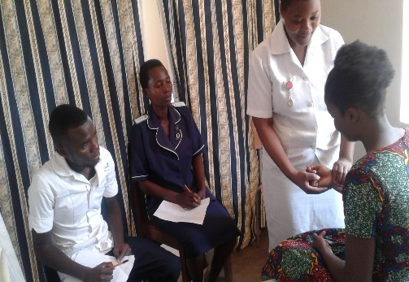

Skills laboratory learning is one of the activities. Students learn in the skills laboratory first before they go for clinical practice


Pioneers of Diploma in nursing leading to registered nursing ( RN 2014 Intake)

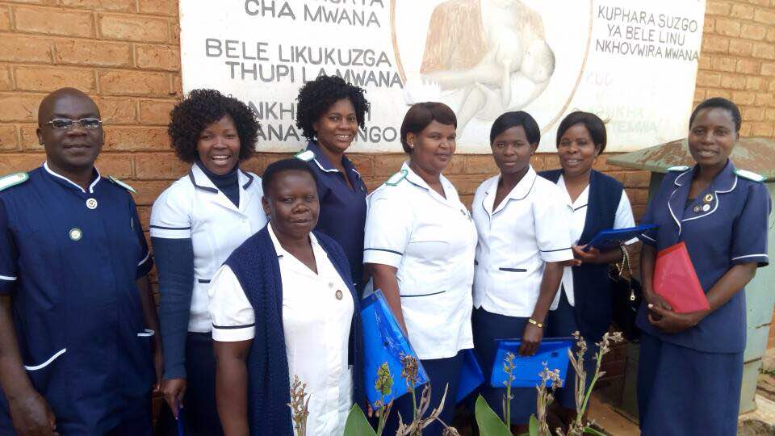

Lectures do not just teach students but they also mentor clinical nurses and midwives

The faculty of Nursing and Midwifery welcome you all and if you join us, we wish you well in studies.

